**Pre-Requsite:-**

**1. Install Java and set the path**

**2. Install “Maven” and set the path**

**3. Install “Cucumber” and “Gherkin” plugins to your IDE. (I use IntelliJ)**

**4. You can install the “SonarLint” plugin to check the code quality**

**To import the project…**

1. Import the .POM file from the API Framework>API>pom.xml
2. After the successful import, run mvn dependency:resolve :- This will download all the dependencies mentioned in the POM.XML
3. After the package download, run “mvn clean install -DskipTests” in the Terminal section of the IDE, for compilation

**Framework explanation in short:-**

**XML File:**- For all the dependencies, plugins and Profiles. We are using Java, TestNG, RestAssured libraries and extent reports for this framework.

**src\main\resources\profile\api\config.properties :-** For the base URI. This file can be used for further parameters

**Environment.properties:-** This file will take the default profile set at the .POM file.

**src\test\java\com\PAMEDIA\test\framework\CommonMethods\APICommonMethods.java :-** This class will have all the common methods for the API, which will reduce the rework.

**src\test\java\com\PAMEDIA\test\framework\ENUMS\APIEndPoints.java**

:- This ENUM has a list of end points.

**src\test\java\com\PAMEDIA\test\framework\Helpers\GetResponse.java**

:- Helper folder will have all the helpers classes. Ex:- GetResponse.java, which will be used to get all the responses.

**src\test\java\com\PAMEDIA\test\framework\hooks\Screenshot\SetAPI.java**

:- hooks folder will have the all the classes which will contain the different hooks. Ex:- @Before, @After hooks where we can initialize the resources and in the @After hook, can have tear down / take screen shots functionalities

**src\test\java\com\PAMEDIA\test\StepDefinitions :-** This folder will have all the list of StepDefs methods which has a linkage to the feature file

**src\test\java\com\PAMEDIA\test\RunAPISuite.java :-** Runner class to run the feature files. We are using TestNG here (and at feature files for Assertions)

**Src\test\resources\features\api :-** All the feature filles will be residing in this folder

**API\target :-** This folder will have generated reports and resources. Ex:- check the “html” folder for the generated extent report

**HOW to Run Scripts**

Right click on the Runner file and select “Run RunAPISuite” option

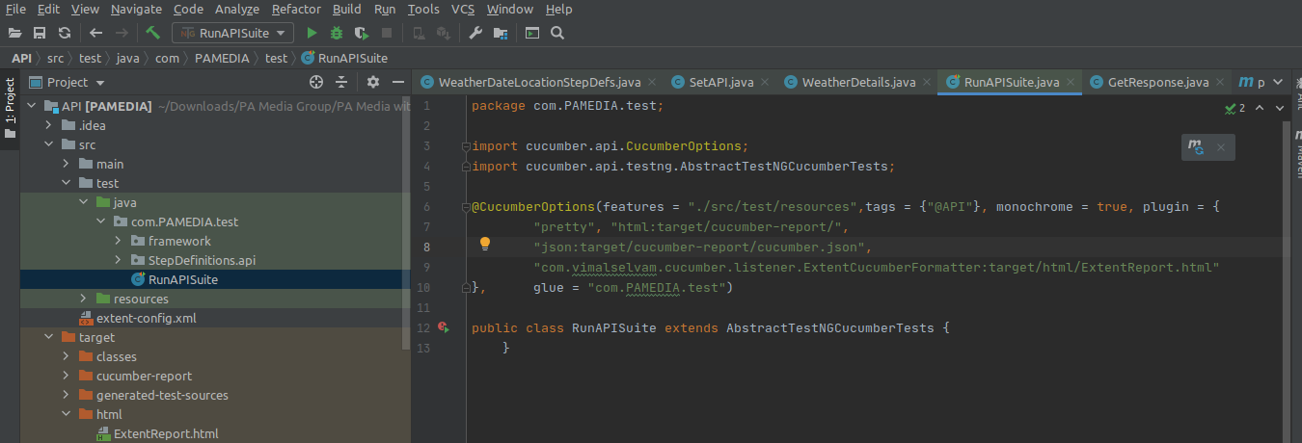

Extent Report Folder location

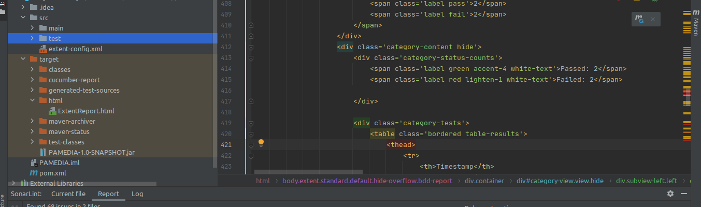

**To Open the extent report with the browser, right click on the report and navigate to “Open in browser” and select the browser. Please check all the sections to see the detailed information.**

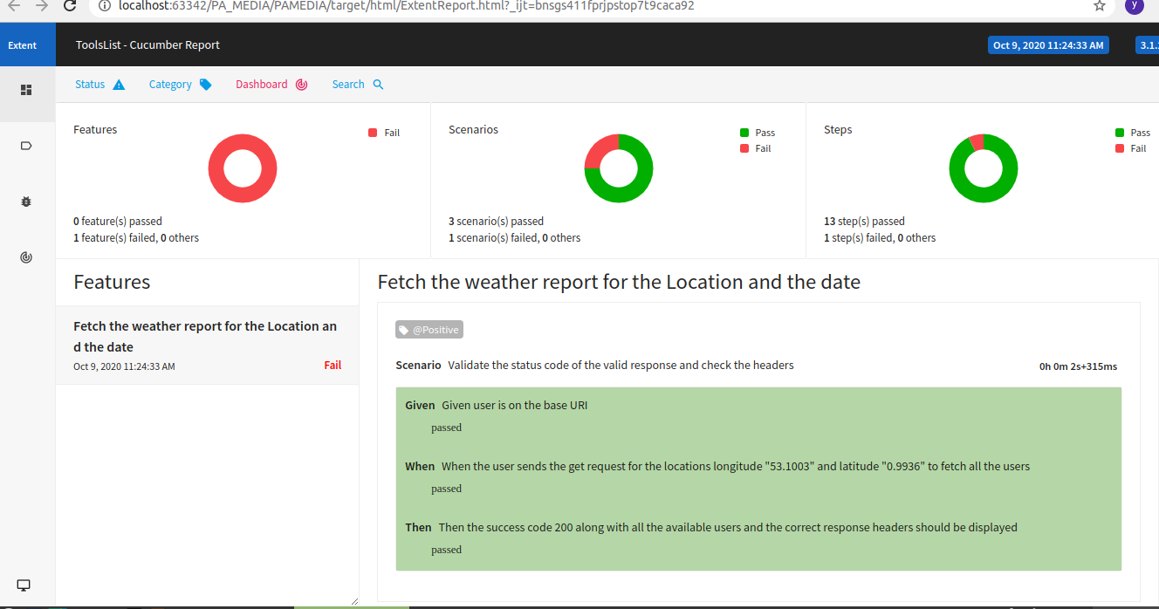

**Future Scope**

1. The same Framework can be used for...

a. Web/UI Application Tests

b.Different Devices Testing

c.Different Browser Testing

areas where we can write the Test cases in BDD format.

2. There is a scope to use the better reporting. We can use Cucumber reports to integrate all the above mentioned areas (in point 1) to generate the report and deliver to the different stake holders.

3. This framework can be used to integrate in CI/CD manner with the configurations to the GIT and Jenkins